**Assignment 24.5**

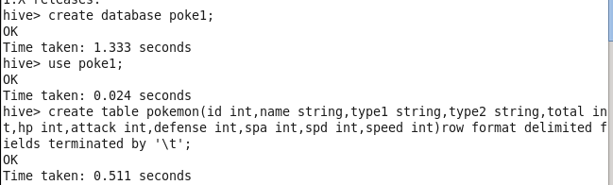

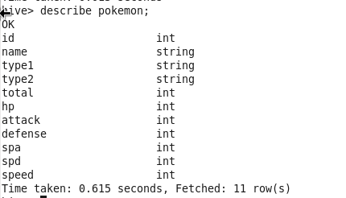



**Dataset**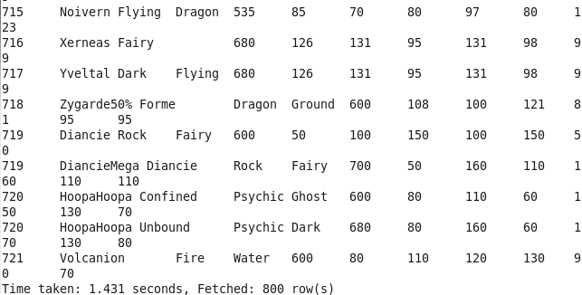

**1. Find out the average HP (Hit points) of all the Pokémons** 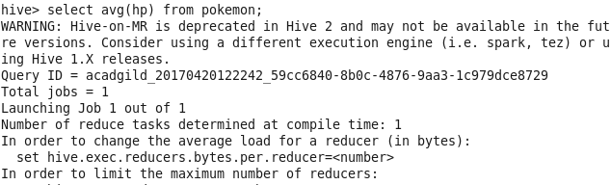

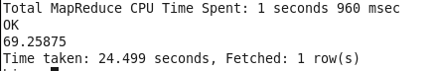

**2. Find out the average Defense of all the pokemon**

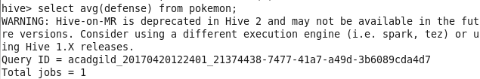



3. Find out the average Sp.Atk of all the pokemons 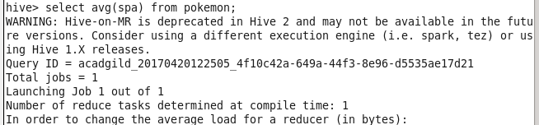



**Q4) 4. Find out the average sp.Def of all the pokemons**

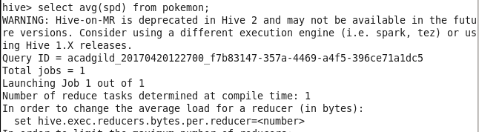

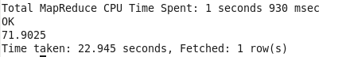

**5. Find out the average Speed of all the pokemons**

